Tuesday 4 October 2016 Jack Jones House, Unite the Union
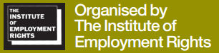Pro-business newspapers continue to reinforce the message that safety is not good for business, a waste of money and resources; this leads to societal acceptance of the downgrading of health and safety regulation and continuous HSE budgetary cuts. At this conference delegates came together from CWU, Unite, Unison, USDAW and some whom were attributed to their business.
Carolyn Jones, Director IER, opened the conference describing the work of the Institute of Employment Rights as being a think tank for the labour movement as well as a charity. They provide informed debate on trade union rights and labour law by providing information, critical analysis, and policy ideas through a network of academics, researchers and legal advisers.
Robert Baughan, Assistant National Officer in the Unison H & S Policy Unit, was the first guest and talked of the interaction between HSE and the unions. Starting from a point of mutual need and mutual antagonism he noted that the unions’ were the biggest friend of the HSE who can be put in a situation of being unable to defend themselves when the have been slight legislative changes such as making each government department look for “economic opportunities” as a primary task. The continued attacks on the tri-partite structure of the HSE and CWU opinion of them are well publicised.
Susan Murray, a National Health and Safety Adviser for Unite, discussed the safety challenges in the workplace. Asbestos eradication is a huge and long term goal for the TUC yet only 50 out of 190 countries in the UN have banned it and attempts to increase that have been blocked by a veto system. Even where there is national legislation there is concern that there is often a legal acceptable limit yet there is no safe asbestos. The schools asbestos campaign Joint Union Asbestos Committee (JUAC) includes several unions but not the CWU. So far this has established a DfE steering group, a DfE school review and asbestos guidance, advice on legacy gas masks and warm air heaters etc.
Philip Liptrot is a solicitor working for Thompsons who specialises in injuries at work; he was able to make the law sound interesting which is no mean feat. Small claims include things like a punctured lung in an RTC and are not the broken fingernail claims as often ridiculed in the media, the compensation culture myth. The government want to lift the small claims limit in RTCs from £1k to £5k meaning the small person who wants legal advice will have to take on insurers at their own cost. This may be introduced to all personal injury cases resulting in the removal of free legal advice for millions of injured people and keep the money in the bank accounts of multinationals. Note that five insurers control 60% of the UK £15b car insurance market and that accident compensation is at an all-time low already. Direct Line and Admiral paid out £2.856bn in shareholder dividends in the last three years.
“Will there be any health, safety or justice at work by 2020?” was led by long-time friend of the CWU, Hilda Palmer from Hazards which provides free independent information, advice and support to workers. Hilda tracked back the last few years and where we have come from, why it has happened and what we can do about. I took less notes during this presentation as Hilda said so much, her slides will be available on the IER website shortly but if she’s ever speaking at an event go and see her, old fashioned motivational speech making.
“Making ‘Better Regulation’: the assault on health and safety protection” was presented by Steve Tombs Professor of Criminology at the Open University. Steve indecently was the source of much of my information when doing my degree a few years ago and a top bloke. Noted that 29,000 deaths each year in the UK are attributable to the effects of airborne pollution and there are 20,000 hospital admissions with around 500 deaths yet the cuts to Las and HSE continue; box below shows what they mean in practice.
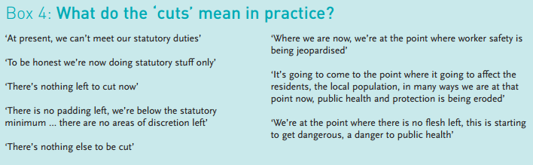
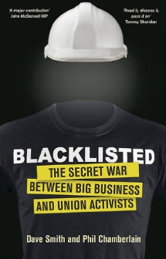The last speaker was as informative as his previous comrades. Dave Smith from the Black List Support Group spoke of the struggle had had encountered when discovering that he was on a construction blacklist. The illegal strategies used by international companies to deny union activist work, many for merely raising safety concerns to management. He spoke of the collusion with police and security services resulting in victimisation and unemployment with the resulting effects on families. His updated book was forwarded by John McDonnell MP, “Blacklisted – the secret war between big business and union activists” and described by Ken Loach the famous film director as “a wakeup call”.

Useful/used resources:
- www.ier.org.uk/manifesto
- www.ier.org.uk/
- www.juac.org.uk
- www.britishasbestosnewsletter.org/index.htm
- www.thompsons.law.co.uk/cutpremiumsnow
- www.crimeandjustice.org.uk/publications/better-regulation-better-whom
- Smith, Dave & Chamberlain Phil. 2nd edition (2016). Blacklisted. London: New Internationalist.

This was another informative event with useful information to take away. There is a one-day conference on “Employment Law Update 2016” on Tuesday 29 November which will be of use to the Branch if anyone from IR is available; at Jack Jones House, Unite the Union NW Office, 9.30am - 3.15pm.

Derek Maylor 5 October 2016 IER Conf Lpool 1016

